Chapter 1 Problem 21 Michael Streyle

##   
## Call:  
## lm(formula = broken ~ route)  
##   
## Coefficients:  
## (Intercept) route   
## 10.2 4.0

## (Intercept)   
## 14.2

## (Intercept)   
## 18.2

## (Intercept)   
## 4

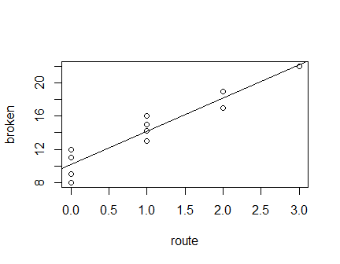

The intercept is 10.2 GPA units and the slope is 4 GPA unit per ACT score increment.